**Retals Business Analysis Project Report**

As an asset management company, looking forward to investing in a few companies, while considering the global trends in investment; this is a brief report of the analysis done to enable Retals make good and data-driven investment decisions. Retals strategy was to invest where most other investors are investing, given these two constraints.

* To invest between 5 to 15 million USD per round of investment
* To invest only in English-speaking countries because of the ease of communication with the companies it would invest in! Hence, for this analysis, only English-speaking countries (or countries which have English as one of their official languages) were put into consideration.

This pattern is often observed among early-stage startup investors.

**General Objective**

The business objectives and goals of data analysis are pretty straightforward.

The main objective of this analysis was to identify the best sectors, countries, and suitable investment types for making investments. The overall strategy was to invest where others are investing, implying that the 'best' sectors and countries are the ones 'where most investors are investing'. This main objective is further subdivided into three broad objectives;

**Broad Objective**

* Investment type analysis: Comparing the typical investment amounts in the venture, seed, angel, private equity etc. so that Retals can choose the type that is best suited for their strategy.
* Country analysis: Identifying the countries which have been the most heavily invested in the past. These will be Retals’s favorites as well.
* Sector analysis: Understanding the distribution of investments across the eight main sectors. (Note that we are interested in the eight 'main sectors' provided in the mapping file.

For this analysis, real investment data was taken from crunchbase.com. The data files for this project were subdivided into three CSV files namely; Companies, Round2 and mapping files

Companies file contains information about different investment company such as name of the company, status, region, category list etc.

Round2 file contains information about the type of investment, raised amount etc.

The mapping file contains information such as different category names in a company

DATA CLEANING

Each dataset was loaded in using the Pandas library, the dataset was checked using ……. (put the data cleaning tool you used) to ensure that all N/A values was removed.

Two datasets (companies and Round2) were merged using the using unique key column present in each dataset to produce a single dataset (Master_frame) for further analysis

OBJECTIVE 1: FUNDING TYPE ANALYSIS

The funding (or investment) type analysis is the first goal of the analysis. The funding types such as seed, venture, angel, etc. depend on the type of the company (startup, corporate, etc.), its stage (early-stage startup, a funded startup, etc.), the amount of funding (a few million USD to a billion USD), and so on. For instance, seed, angel and venture are three common stages of startup funding. Seed/angel funding refers to early-stage startups whereas venture funding occurs after seed or angel stage/s and involves a relatively higher amount of investment. Private equity-type investments are associated with much larger companies and involve much higher investments than venture types. Startups which have grown in scale may also receive private equity funding. This means that if a company has reached the venture stage, it would have already passed through the angel or seed stage/s.

Considering that Retals wants to invest between 5 to 15 million USD per investment round, this analysis was able to pinpoint that VENTURE is the most suitable type of investment. The most representative value of the investment amount for each funding type was calculated. According to the analysis, the mean could not be used to select the most representative investment type. This was because the amount invested for each funding type is positively skewed as shown by the summary statistics, which signifies the presence of an outlier, hence, making the median the appropriate measure for the suitable investment type.

Funding Type Raised amount (in dollars)

|  |  |  |
| --- | --- | --- |
| **private_equity** |  | 20000000.0 |
| **Venture** |  | 5000000.0 |
| **Angel** |  | 425000.0 |
| **Seed** |  | 300000.0 |

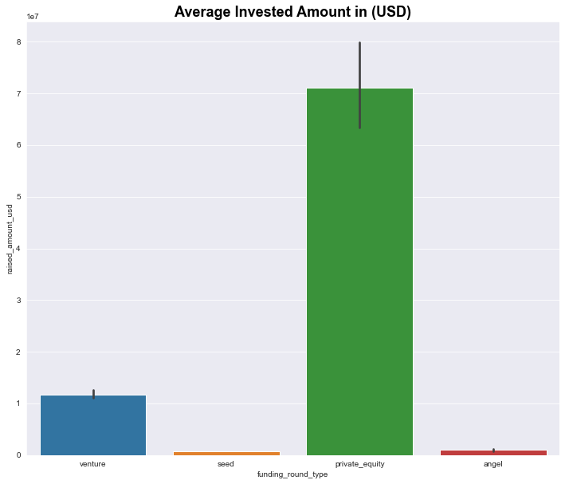

Fig 1.1: A plot showing the average amount of investment in each funding type

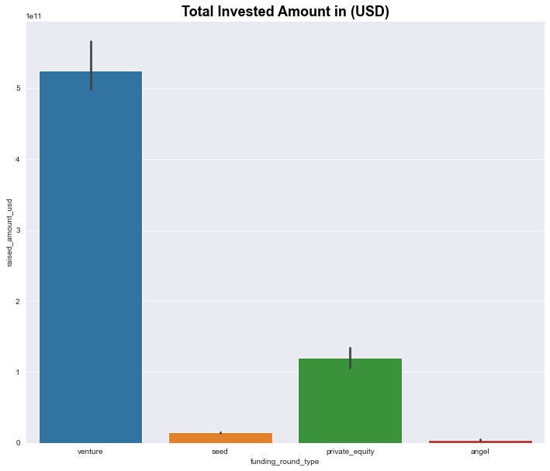

Fig 1.2: A plot showing the fraction of total investments (globally) in the venture, seed, and private equity

OBJECTIVE 2: COUNTRY ANALYSIS

This is the second goal of the analysis. Bearing in mind that Retals constraint wanted to invest in only English-speaking countries. The top 9 countries with track records of heavy investment are shown in the table below:

USA 3.978218e+11

CHN 3.562355e+10

GBR 1.863205e+10

IND 1.383492e+10

CAN 8.895475e+09

FRA 6.666626e+09

ISR 6.367861e+09

DEU 6.088517e+09

JPN 3.011058e+09

Based on the above analysis, the top three English-speaking countries are:

Top English-speaking country Canada (CAN)

Second English-speaking country United States of America (USA)

Third English-speaking country Great Britain (GBR)

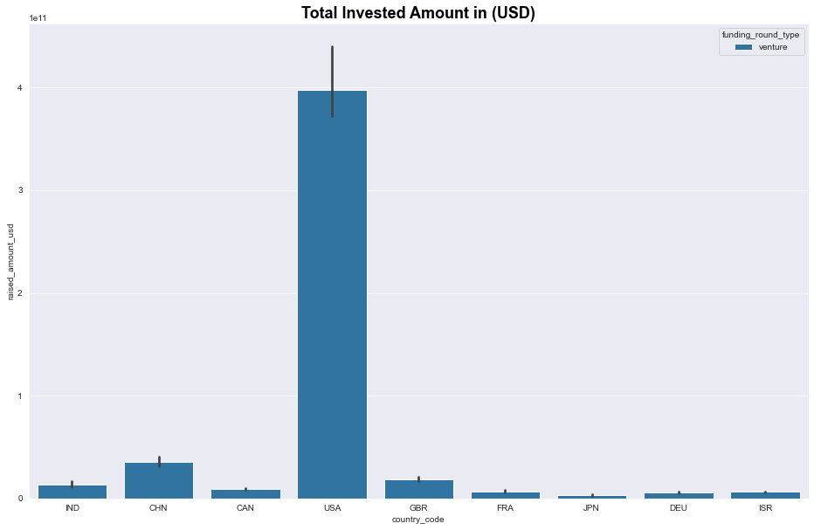

Fig 2: A plot showing the top 9 countries against the total amount of investments of funding type FT

OBJECTIVE 3: SECTOR ANALYSIS

The aim is to understand the distribution of investments across the eight main sectors. The sector analysis is into two parts:

1. Grouping the numerous category lists in the mapping file
2. Identifying the main sectors and countries, Retals should invest in by finding out the most heavily invested main sectors in each of the three countries.

The table below shows the most invested sector in terms of the total amount invested and the total number of investments in the top 3 English-Speaking countries

| **country_code** | **main_sectors** | **Total amt invested** | **Count of investment** |
| --- | --- | --- | --- |
| **CAN** | **Cleantech / Semiconductors** | 9.386637e+08 | 104 |
| **Entertainment** | 1.600221e+08 | 23 |
| **Health** | 1.621451e+08 | 20 |
| **Manufacturing** | 2.306331e+08 | 30 |
| **News, Search and Messaging** | 3.786711e+08 | 42 |
| **Others** | 8.249901e+08 | 97 |
| **Social, Finance, Analytics, Advertising** | 6.461431e+08 | 77 |
| **GBR** | **Cleantech / Semiconductors** | 1.016761e+09 | 113 |
| **Entertainment** | 4.647237e+08 | 54 |
| **Health** | 1.867220e+08 | 20 |
| **Manufacturing** | 3.046903e+08 | 34 |
| **News, Search and Messaging** | 5.779207e+08 | 68 |
| **Others** | 1.155156e+09 | 132 |
| **Social, Finance, Analytics, Advertising** | 1.042295e+09 | 127 |
| **USA** | **Cleantech / Semiconductors** | 2.005947e+10 | 2173 |
| **Entertainment** | 4.953440e+09 | 575 |
| **Health** | 7.745753e+09 | 855 |
| **Manufacturing** | 6.827639e+09 | 754 |
| **News, Search and Messaging** | 1.351189e+10 | 1534 |
| **Others** | 2.441200e+10 | 2744 |
| **Social, Finance, Analytics, Advertising** | 2.325846e+10 | 2648 |

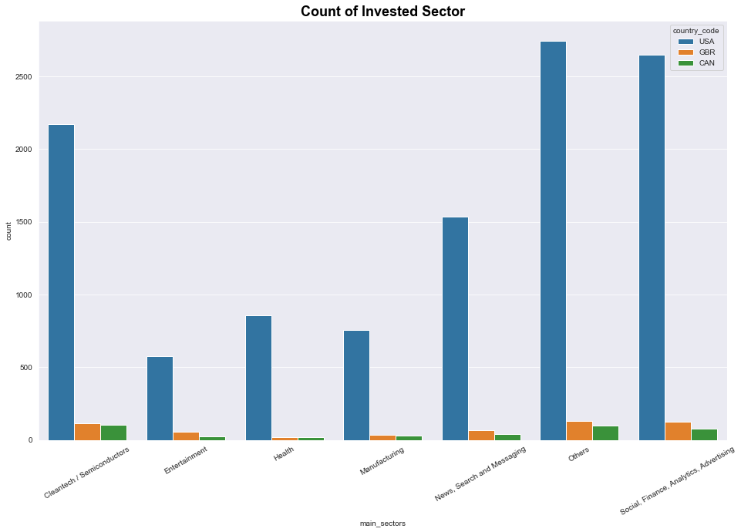

Fig 3.1: A plot showing the number of investments in the top 3 sectors of the top 3 countries

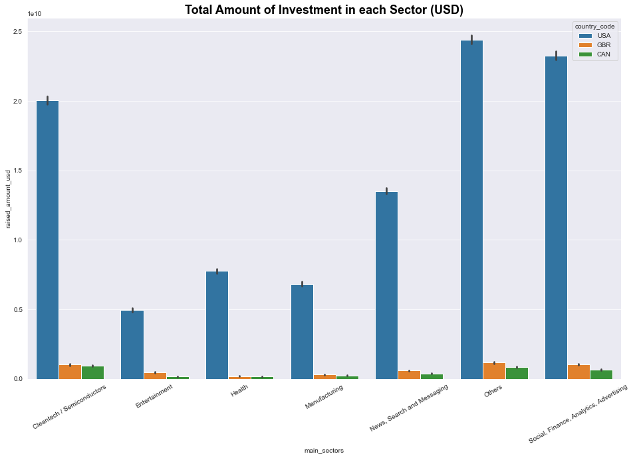

Fig 3.2: A plot showing the total amount invested in the top 3 sectors of the top 3 countries

CONCLUSION

Based on the above analysis, it can be concluded that Retals would be making a good and wise decision choosing VENTURE investment type and the best sectors would be the cleantech, entertainment, health, manufacturing, social /finance/advertising, news/messaging and others across the United States of America, Great Britain and Canada.